**Home Page/Login Page:**

Home.html

{% extends 'index.html' %}  
{% block title %}Home{% endblock title %}  
  
{% block style %}  
 <link rel="stylesheet" href="/static/css/homestyle.css">  
{% endblock style %}  
  
{% block content %}  
 <div class="outer_box">  
 <div class="about_box">  
 <div>  
 <h2>Plasma Donor Application</h2>  
 <p>During the COVID 19 crisis, the requirement of plasma became high and the donor count being low. It’s very difficult to find the respective blood group donors when anyone is in need. The Plasma Application helps people to find a plasma donors easily.</p>  
 </div>  
 </div>  
 <div class="form_box">  
 *<!-- Didn't add middleware yet" -->* <form method="POST" autocomplete="off" id="Login_form" action="/login">  
 <h3 class="d-flex justify-content-center">Login</h3>  
 <div class="mt-2">  
 <h6>Username</h6>  
 <input class="form-control" type="text" name="email" placeholder="example123@gmail.com">  
 </div>  
 <div class="mt-2">  
 <h6>Password</h6>  
 <input class="form-control" type="password" name="password" placeholder="Password">  
 </div>  
 <div class="mt-2 d-flex justify-content-end">  
 <a style="font-size: 13px; color: #ffffff" href="#">Forgot Password?</a>  
 </div>  
 <div class="d-grid gap-2 mt-2">  
 <button class="btn btn-light" type="submit">Login</button>  
 </div>  
 <div class="mt-2">  
 <p style="font-size: 15px">Don't have an account? <a style="color: white; text-decoration: underline" href="#">Create Account</a></p>  
 </div>  
 </form>  
 </div>  
 </div>  
 <nav class="navbar navbar-expand-lg">  
 <div class="brand_box">  
 <a class="navbar-brand" href="#">IBM Plasma Donor</a>  
 </div>  
 </nav>  
{% endblock content %}

Homestyle.css

*{  
 font-family: Arial, serif;  
 color: #ffffff;  
}  
  
.navbar-brand{  
 color: #ffffff;  
 font-weight: bolder;  
 font-size: 30px;  
 text-shadow: 2px 2px 4px #000000;  
}  
  
.brand_box{  
 position: relative;  
 margin-left: 5rem;  
 display: flex;  
 align-items: center;  
 justify-content: start;  
}  
  
.outer_box{  
 height: 100%;  
 width: 100%;  
 position: absolute;  
 top: 0;  
 bottom: 0;  
 display: flex;  
 align-items: center;  
 justify-content: center;  
 padding-bottom: 4rem;  
}  
  
.form_box{  
 top: 4rem;  
 position: relative;  
 margin: auto 7.5rem auto auto;  
 border: 2px solid white;  
 border-radius: 20px;  
 padding: 70px;  
 display: flex;  
 align-items: center;  
 justify-content: center;  
 background-color: rgba(0,0,0, 0.2);  
}  
  
.about_box{  
 top: 4rem;  
 width: 40%;  
 position: relative;  
 margin: auto auto auto 5rem;  
 padding: 10px;  
 display: flex;  
 align-items: center;  
 justify-content: center;  
}  
  
.form-control:focus{  
 box-shadow: none;  
}  
  
.form-control::placeholder{  
 font-size: 13px;  
 opacity: 0.5;  
}  
  
*/*Tag Property*/*body{  
 background-image: linear-gradient(90deg, darkorange, orange, yellow);  
 background-attachment: fixed;  
 background-position: center center;  
 background-repeat: no-repeat;  
 background-size: cover;  
}  
  
a{  
 text-decoration: none;  
}  
  
h2{  
 font-weight: bolder;  
}  
  
p{  
 text-align: justify;  
 text-justify: inter-word;  
}

**Registration Page:**

User_registration.html

{% extends 'index.html' %}  
{% block title %}New User - Register{% endblock title %}  
  
{% block style %}  
 <link rel="stylesheet" href="/static/css/homestyle.css">  
 <link rel="stylesheet" href="/static/css/register/user_register.css">  
{% endblock style %}  
  
{% block content %}  
 <div class="outer_box2">  
 <div class="form_box2">  
 <form method="POST" autocomplete="off" id="user_register_form" action="/formreg">  
 <h3 class="d-flex justify-content-center pb-2" style="font-weight: bold">Registration Form</h3>  
 <div class="row g-1 align-items-center">  
 <label for="firstname" class="col-4 col-form-label">First Name</label>  
 <div class="col">  
 <input class="form-control" id="firstname" type="text" name="fname">  
 </div>  
 </div>  
 <div class="row g-1 align-items-center mt-2">  
 <label for="lastname" class="col-4 col-form-label">Last Name</label>  
 <div class="col">  
 <input class="form-control" id="lastname" type="text" name="lname">  
 </div>  
 </div>  
 <div class="row g-1 align-items-center mt-2">  
 <label for="email_id" class="col-4 col-form-label">Email</label>  
 <div class="col">  
 <input class="form-control" id="email_id" type="email" name="email">  
 </div>  
 </div>  
 <div class="row g-1 align-items-center mt-2">  
 <label for="mob_num" class="col-4 col-form-label">Mobile No.</label>  
 <div class="col">  
 <input class="form-control" id="mob_num" type="text" name="phonenumber">  
 </div>  
 </div>  
 <div class="row g-1 align-items-center mt-2">  
 <label for="pwd1" class="col-4 col-form-label">Password</label>  
 <div class="col">  
 <input class="form-control" id="pwd1" type="password" name="password1">  
 </div>  
 </div>  
 <div class="row g-1 align-items-center mt-2">  
 <label for="pwd2" class="col-4 col-form-label">Confirm Password</label>  
 <div class="col">  
 <input class="form-control" id="pwd2" type="password" name="password2">  
 </div>  
 </div>  
 <hr>  
 <div class="d-grid gap-2">  
 <button class="btn btn-primary" type="submit">Submit</button>  
 </div>  
 </form>  
 </div>  
 </div>  
 <nav class="navbar navbar-expand-lg">  
 <div class="brand_box">  
 <a class="navbar-brand">IBM Plasma Donor</a>  
 </div>  
 </nav>  
{% endblock content %}

User_register.style

*{  
 font-family: Arial, serif;  
 color: #ffffff;  
}  
  
body{  
 background-image: linear-gradient(90deg, darkorange, orange, yellow);  
 background-attachment: fixed;  
 background-position: center center;  
 background-repeat: no-repeat;  
 background-size: cover;  
}  
  
.form-control{  
 line-height: 1.2;  
 font-size: 1rem;  
 width: 15rem;  
}  
  
.outer_box2{  
 height: 100%;  
 width: 100%;  
 position: absolute;  
 top: 0;  
 bottom: 0;  
 display: flex;  
 align-items: center;  
 justify-content: center;  
}  
  
.form_box2{  
 position: absolute;  
 margin: 4rem 7.5rem auto auto;  
 border: 2px solid white;  
 border-radius: 20px;  
 padding: 60px;  
 display: flex;  
 align-items: center;  
 justify-content: center;  
 background-color: rgba(0,0,0, 0.2);  
}

New User Registration:

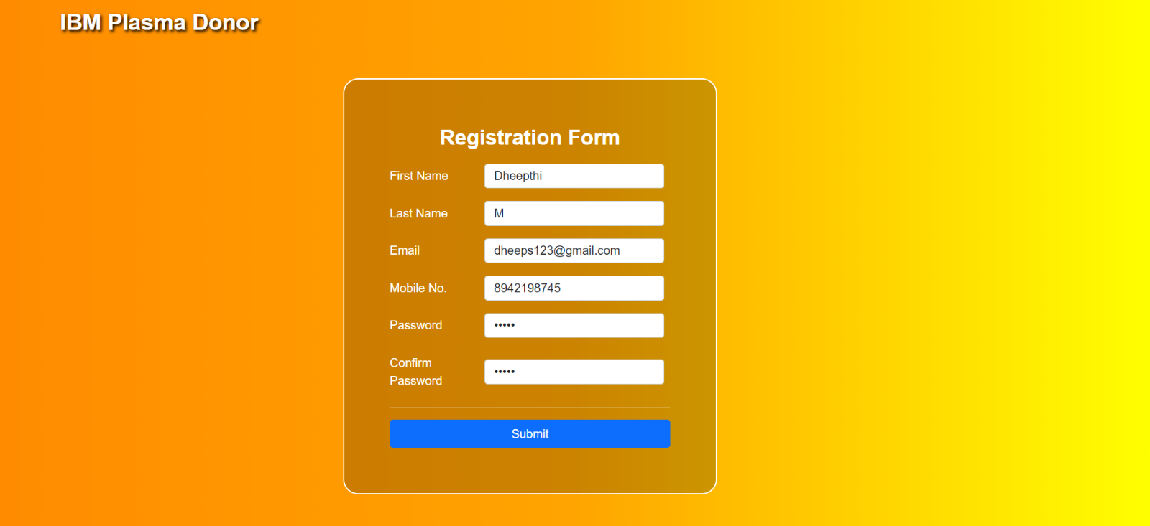

User Created:



If User Already Exist:



User Login:

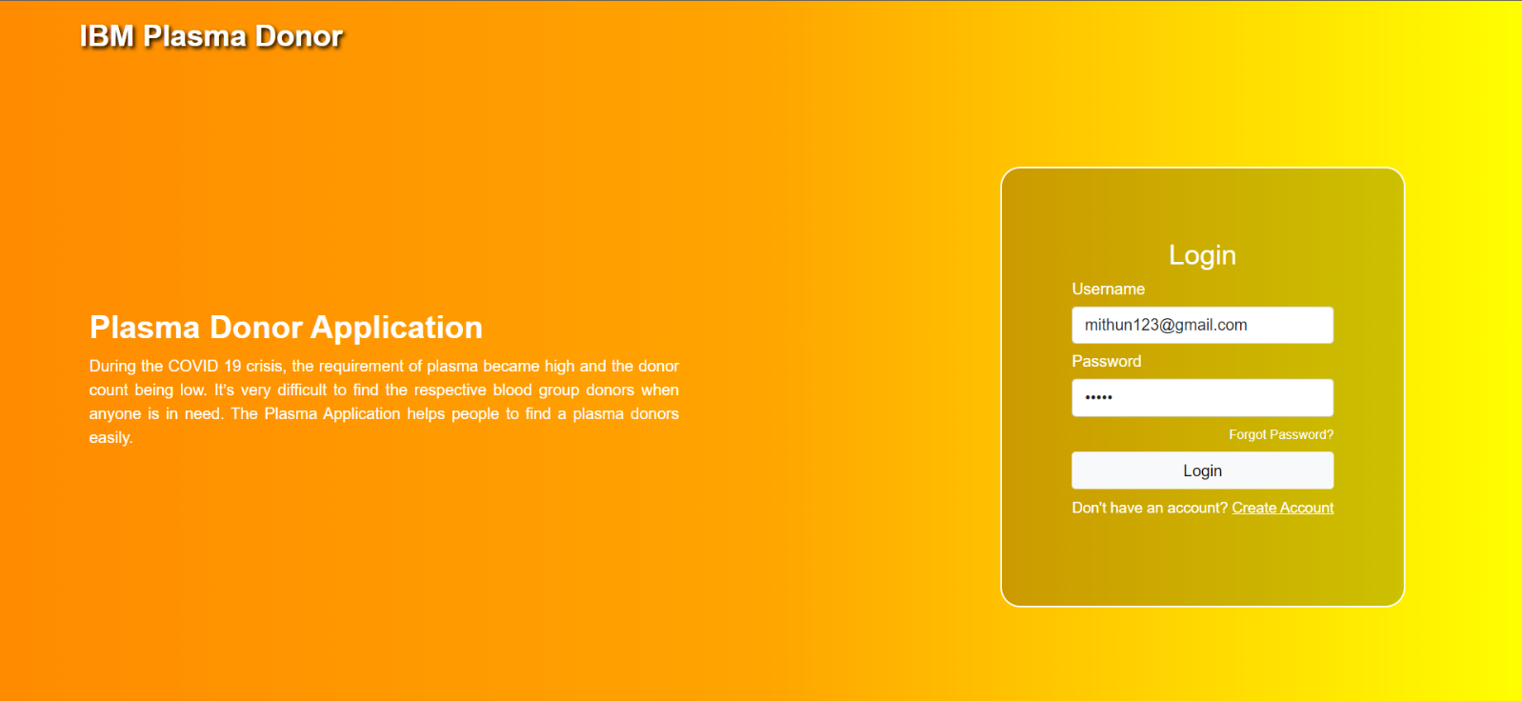

User Logged In:



User Table:

